Cataract:
A cataract is a clouding of the normally clear lens of your eye. For people who have cataracts, seeing through cloudy lenses is a bit like looking through a frosty or fogged-up window.
Clouded vision caused by cataracts can make it more difficult to read, drive a car (especially at night) or see the expression on a friend's face.
Most cataracts develop slowly and don't disturb your eyesight early on. But with time, cataracts will eventually interfere with your vision.
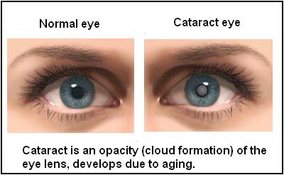

Osteoporosis:
Osteoporosis causes bones to become weak and brittle — so brittle that a fall or even mild stresses like bending over or coughing can cause a fracture. Osteoporosis-related fractures most commonly occur in the hip, wrist or spine.
Bone is living tissue that is constantly being broken down and replaced. Osteoporosis occurs when the creation of new bone doesn't keep up with the removal of old bone.
Osteoporosis affects men and women of all races. But white and Asian women — especially older women who are past menopause — are at highest risk. Medications, healthy diet and weight-bearing exercise can help prevent bone loss or strengthen already weak bones.
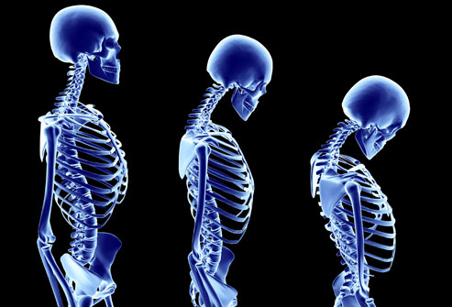

Myopathy:
Myopathy can take on many forms, but no matter how it manifests, myopathy occurs when muscle fibers in the body become permanently damaged. Depending on how it presents, myopathy can drastically affect some people's lives, while others are not as impaired. Certain exercises may help you, depending on what type of myopathy you have. Exercise alone is not a cure for myopathy, but is used as therapy to relieve your symptoms.

Signs and Symptoms
The primary symptom of myopathy is muscle weakness, notes the National Institute of Neurological Disorders and Stroke. Weakness can be accompanied by stiffness, pain and spasms. Chronic muscle cramps are also a sign of some myopathy.

Types
Types of myopathies include defects in skin, bone, skeletal muscles and developmental skills. Exercise can help those with myopathies that affect the skeletal muscles. Mitochondrial myopathy is characterized by defects in the mitochondria of the cell. The mitochondria are responsible for energy production for working muscles. Muscular dystrophy is characterized by uncontrollable spasms and weakness of the muscle. Polymyositis is inflammation of the skeletal muscles.
Picture of a teenager with Myopathy affecting her muscles

Arthritis: Arthritis is inflammation of one or more of your joints. The main symptoms of arthritis are joint pain and stiffness, which typically worsen with age. The most common types of arthritis are osteoarthritis and rheumatoid arthritis.
Osteoarthritis causes cartilage — the hard, slippery tissue that covers the ends of bones where they form a joint — to break down. Rheumatoid arthritis is an autoimmune disorder that first targets the lining of joints (synovium).
Uric acid crystals, infections or underlying disease, such as psoriasis or lupus, can cause other types of arthritis. Treatments vary depending on the type of arthritis. The main goals of arthritic treatments are to reduce symptoms and improve quality of life. 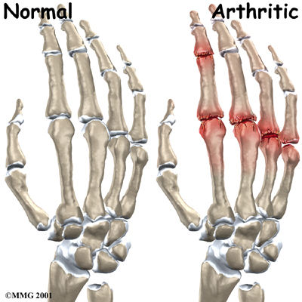

Restriction: the limitation or control of someone or something, or the state of being limited or restricted.
Mobility: the ability to move or be moved freely and easily.
Simulation: imitation or enactment or the act or process of pretending

